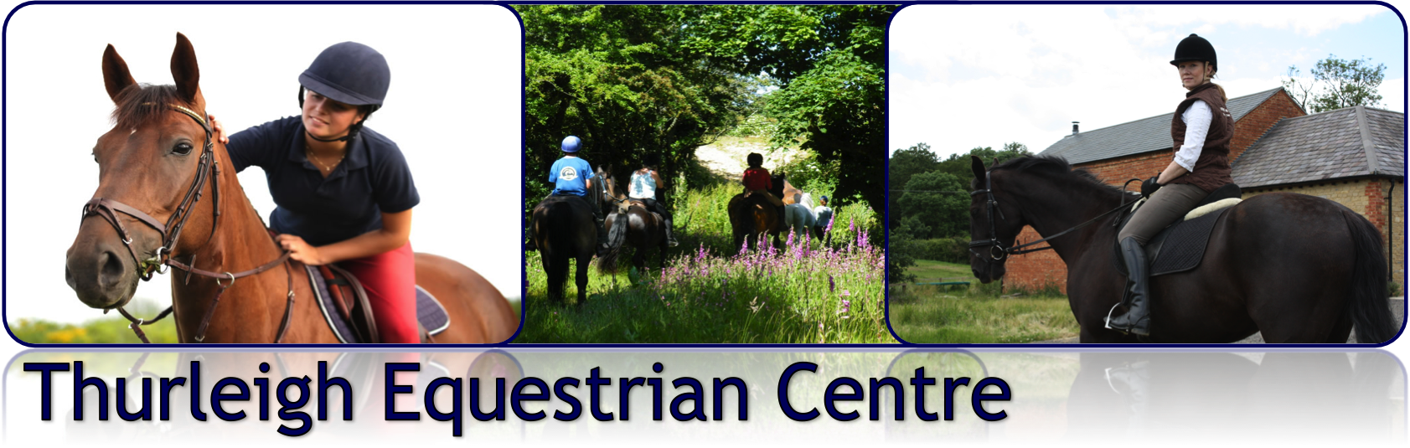
FEBRUARY DRESSAGE CLINICS WITH MARK TOWNSEND BHSI

Thurleigh Equestrian Centre – Indoor Arena

Mark is an experienced dressage rider and trainer, currently competing at Grand Prix level, he has trained under several leading instructors including Jenny Ward (List 1 Judge), Sarah Dwyer- Coles (International Dressage Rider) and Jennie Loriston-Clarke. He has won the Pat Smallwood Training Award, The Young Trainer’s Award and was voted the ‘Your Horse’ magazine ‘Instructor of the Year’. He teaches all abilities from the regular competitor to new rider and those that want to improve how their horse goes and have fun.

Dates for February Clinics

Sunday 3rd February – 10am to 4pm
1 hour session @ £40.00 per hour in indoor arena.

Sunday 24th February – 10am to 4pm
1 hour session @ £40.00 per hour in indoor arena.

Cancellation Policy

Any clinic sessions booked and cancelled within 36hrs will be charged for unless a replacement rider can be found to take the space.

Booking Form

Rider Name / Horse | Sunday 3rd Feb | Sunday 24th Feb | Preferred Time  (10am – 4pm)

I agree to abide by the Thurleigh Equestrian Centre Yard Rules overleaf and have read the cancellation policy

THURLEIGH EQUESTRIAN CENTRE YARD RULES

These rules are here to ensure that the yard remains a safe and enjoyable environment for all who use it and we appreciates your support in upholding them:

- All equipment, vehicles and horses brought onto premises at Thurleigh Equestrian Centre are brought here at your own risk and the Centre take no responsibility for any damage or losses incurred when visiting the premises.

- Please be considerate to other riders when sharing arenas, passing left to left and walking on an inside track.

- NO riding or grazing on the grass areas please.

- NO Schools/Arenas may used for turnout or loose jumping without prior permission.

- NO lunging, loose schooling or loose jumping are permitted in the indoor arena.

- Please turn stable and arena lights off if you are the last to leave the yard or arena.

- Please remove droppings on the yard and schools/arenas after each use. The Owner will be subject to a nominal fine if not removed.

- Please report any breakages of show jumps, dressage boards, fences etc to the office immediately.

- Health and safety procedures set out by the Yard must be strictly adhered to. Smoking on the Yard is strictly forbidden - anyone found smoking on the premises will be asked to leave immediately.

- Please drive considerately and slowly around the yard and only park in designated parking areas.

- Anyone under the age of 16 years old must be accompanied by an adult at all times.

- Dogs are welcome on the yard, but must be kept on a lead at all times. The Yard reserves the right to ask for any dog deemed to be causing a nuisance to be removed. All dog mess must be cleared up immediately.

